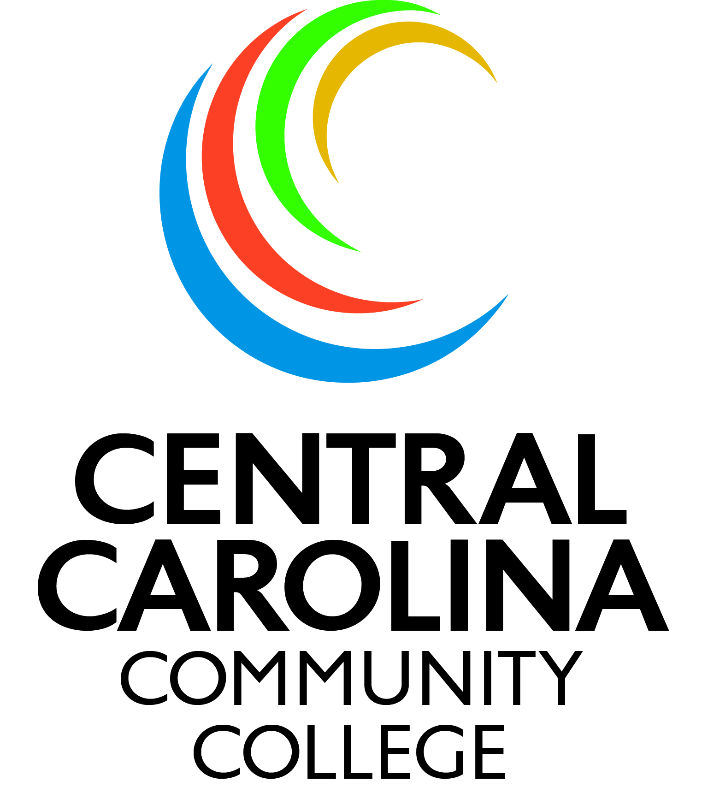
Central Carolina Community College
Upward Bound Math and Science Program

Application of Admission

Dear Applicant:

The Upward Bound Math and Science (UBMS) Program at Central Carolina Community College is a federally funded educational program which prepares high school students for college and careers in the fields of math and science. The UBMS Program at CCCC serves Harnett County students attending the following high schools: Harnett Central High School, Overhills High School, STAR Academy, Triton High School, and Western Harnett High School. Students must be in the 9th or 10th grade at the time of admission into the program.

If you are interested in participating in the Upward Bound Math and Science Program, please follow the below instructions in order to complete the application process:

- Complete the entire application packet by supplying all of the required information as outlined.
- Submit a copy of parent’s 1040 or 1040A Income Tax Return for the previous year. (Tax return must include parent’s signature).
- Submit a copy of student’s high school transcript or most recent report card and test scores.
- Sign the Release of Information Form so that your school’s guidance department will release your academic record to the Upward Bound Math and Science Program.
- Submit two (2) letters of recommendation: One (1) from an academic teacher and one (1) from your high school counselor.
- Return the completed application to: Upward Bound Math and Science Program, Attn: Office of TRIO Programs, Central Carolina Community College, 1105 Kelly Drive, Sanford, NC 27330.

Your application cannot be processed without completing all of the requested information. Once your application has been received, you will be notified by mail of your application status. If you have any questions, please contact our office at (919) 718-7463. Thank you for your interest in our Upward Bound Math and Science Program!

Sincerely,
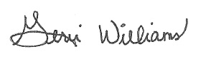

Dr. Gerri B. Williams
Director of TRiO Programs

PRIVACY ACT STATEMENT:
The personal information that you give to the Upward Bound Math and Science Program is sent to the federal government (Department of Education). The information is protected by the Privacy Act. No one may see the information unless they work with or for the Upward Bound Math and Science Program or are specifically authorized to see the information. The information is necessary to determine if you are eligible to participate in the program and helps the government to measure your success. The Department of Education has the authority to gather information to help make Upward Bound Math and Science a better program (20 USC 1231a).

Upward Bound Math and Science Program
Application for Admission

Today’s Date:
I. Student Biographical Profile
Name:
Last First Middle
Address:
Number & Street City State Zip
Social Security #: Home #:
Email Address: Cell #:
Sex: Female Male Date of Birth:
Place of Birth:
I live with: Both Parents: Mother: Father: Guardian:
Are you a U.S. citizen? If no, state legal status:
Race/Ethnicity (check all that apply): African American/Black: American Indian: Alaskan Native: Asian: Hispanic: White:
Native Hawaiian: Native American Pacific Islander:
II. Academic Profile
High School: Grade:
List extra-curricular activities in which you are presently engaged (sports, church, employment, clubs, etc.):
List honors or awards you received in the 8th or 9th grade:
III. Autobiographical Data
Upward Bound was recommended to me by:
A college experience is a part of my career plans. Yes No
If selected to participate in UBMS, I will attend ALL Saturday, Afterschool and Summer components of the program. Yes No
For UBMS Use ONLY:
1 = Low Income & First Generation
2 = Low Income only
3 = First Generation only

My favorite subject in school is:
My career choices are: 1st 2nd
3rd 4th
IV. Household Parental/Guardian Information (only parents living in your home)
Mother’s Name:
Last First Middle
Occupation:

Employer:
Name Complete Address
Email Address: Cell No:
Highest Grade Completed: 1 2 3 4 5 6 7 8 9 10 11 12 College Completed: 1 2 3 4
Name of College, if applicable: Degree:
Father’s Name:
Last First Middle
Occupation:

Employer:
Name Complete Address
Email Address: Cell No:
Highest Grade Completed: 1 2 3 4 5 6 7 8 9 10 11 12 College Completed: 1 2 3 4
Name of College, if applicable: Degree:
List ALL persons living in your household (including yourself) below. Be sure to list all parents, children and any others who live in your household.

Name Age Name of School or College Grade
Or Occupation

*Please be sure to include a copy of Parent(s)’/Guardian(s)’ Income Tax Returns for the most recent year with your completed application packet.

PARENT CERTIFICATION
I, (We) declare that the information provided in this application is complete and accurate to the best of my (our) knowledge.

Father or Male Guardian’s Signature

Mother or Female Guardian’s Signature

Date

All information on this application will be held in strict confidence. This information is necessary to insure that the applicant meets the criteria for admission as established by the U.S. Department of Education.

The Upward Bound Math and Science Program
Central Carolina Community College
1105 Kelly Drive
Sanford, NC 27330
Phone: (919) 718-7463

Release of Information Authorization

Student’s Name:

Birthdate:

High School:

I hereby authorize the release of my child’s high school academic records, including test data, report cards and transcripts to the Upward Bound Math and Science Program at Central Carolina Community College for the duration of his/her enrollment in the program, with the understanding that is information will be used solely for the purpose of assessment, academic planning and reporting.

Name of Parent/Guardian (please print)

Signature of Parent/Guardian Date

The Upward Bound Math and Science Program
Central Carolina Community College
1105 Kelly Drive
Sanford, NC 27330
Phone: (919) 718-7463

Counselor Recommendation Form

Please complete this form and place it in a sealed envelope. You may give it to the student applicant or mail it to the Upward Bound Math and Science Program office.

Student’s Name:

Academic Potential:
Top One Percent  5 | Exceptional  4 | Above Average  3 | Average  2 | Below Average  1

Academic Skills:
Top One Percent  5 | Exceptional  4 | Above Average  3 | Average  2 | Below Average  1

Social Development:
Top One Percent  5 | Exceptional  4 | Above Average  3 | Average  2 | Below Average  1

Comments:
*Please attach a copy of the student’s transcripts and standardized test scores. Thank you.

Signature: Date:
The Upward Bound Math and Science Program
Central Carolina Community College
1105 Kelly Drive
Sanford, NC 27330
Phone: (919) 718-7463

Teacher Recommendation Form

Please complete this form and place it in a sealed envelope. You may give it to the student applicant or mail it to the Upward Bound Math and Science Program office.

Student’s Name:

Academic Potential:
Top One Percent  5 | Exceptional  4 | Above Average  3 | Average  2 | Below Average  1

Academic Skills:
Top One Percent  5 | Exceptional  4 | Above Average  3 | Average  2 | Below Average  1

Social Development:
Top One Percent  5 | Exceptional  4 | Above Average  3 | Average  2 | Below Average  1

Need for Academic Support/Academic Deficiencies:
Comments:

Signature: Date:

