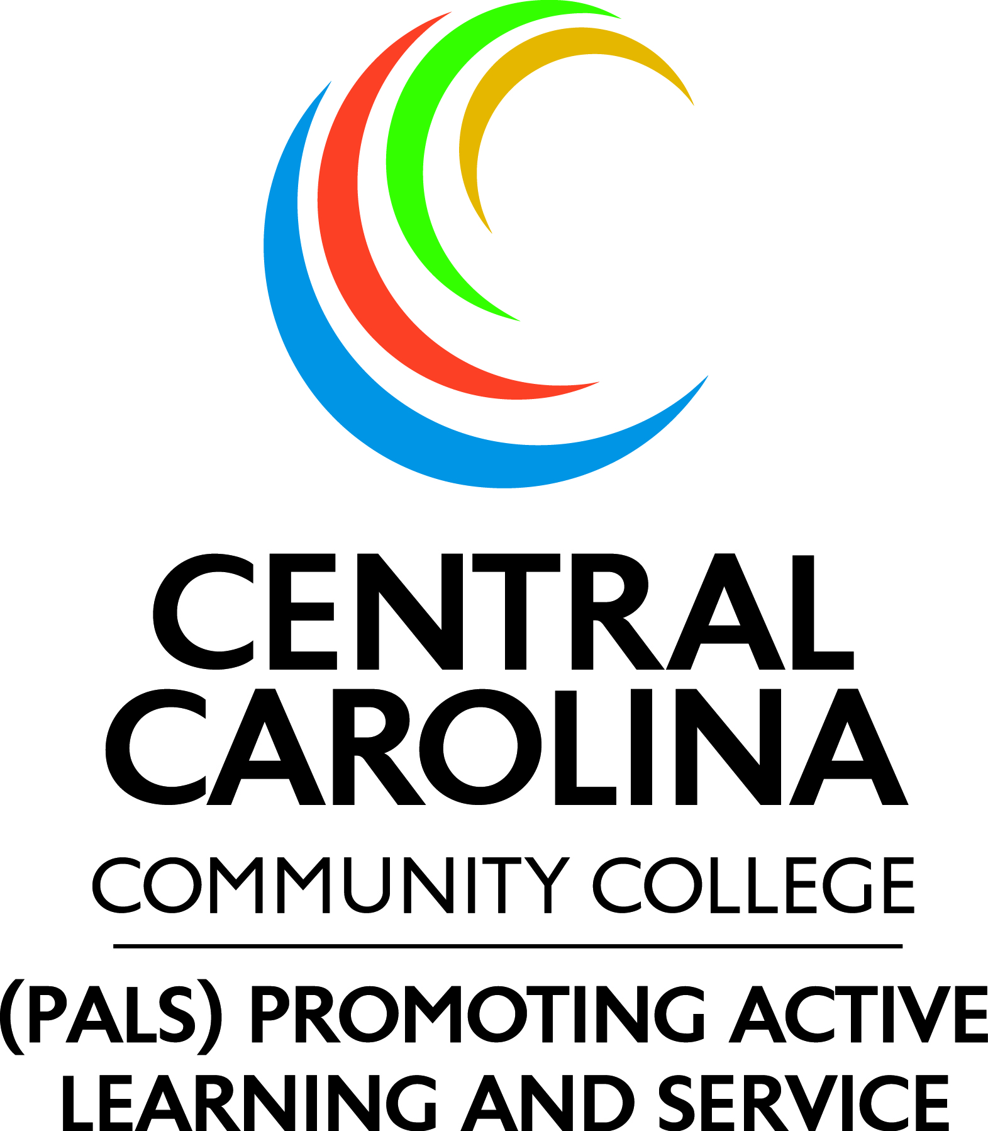
SERVICE-LEARNING REFLECTION FORM
INSTRUCTIONS: The reflection form should be completed by the student. It may be replaced by an essay-style paper assigned by the instructor but must address each of the questions below.
Name: Date:
Student ID: Course:
Service-Learning Project:
- How did this experience help you to better understand your responsibilities and roles as a citizen?
____________________________________________________________________________
____________________________________________________________________________
____________________________________________________________________________

- What skills and knowledge did you acquire through this experience?
____________________________________________________________________________________________________________________________________________________________________________________________________________________________________

- How did your service impact your school or community? How do you know?
____________________________________________________________________________________________________________________________________________________________________________________________________________________________________

- How did this experience help you better understand ideas or subjects you have been studying?
____________________________________________________________________________________________________________________________________________________________________________________________________________________________________

- Comment on at least two character traits you have further developed during this experience.
________________________________________________________________________________________________________________________________________________________

- How will you use what you learned in other situations?
________________________________________________________________________________________________________________________________________________________
5

