Before class
Taking Notes
(and getting the most out of them)

Complete the assigned reading/ project before coming to class.
If available, print and review PowerPoint slides before coming to class.
Where you sit is important:
Position yourself in the front and center of the classroom.
Review notes from previous class before the instructor begins.
- What were the main points?
- How do the notes connect to today’s lecture?
Have the right materials ready before class begins:
- Good pen/ pencil
- Notebook/folder devoted to the subject
- Clean notepaper

Why Take Notes?
It helps you concentrate in class
Your notes are often a source of valuable clues for what information the instructor thinks most important
Your notes often contain information that cannot be found elsewhere
Different Notetaking Methods

Cornell Method

Reading & Lecture Notes Together
Reading Notes
Prior to class,
take notes on
your reading on
one page.
Combined, you will have
notes from your reading
and lectures in one place!
Class Notes
During class, take
notes from the
lecture on the back
of reading notes
pages.

Cue
Column
Take notes here
during class.
Summary Area

Cue Column: Questions, Connections, etc. Summary Area: Condense page to 1-2 sentences

TIP: A professor is about to make a main point when (s)he:
- Pauses before or after an idea
- Uses repetition to emphasize a point
- Uses introductory phrases to precede an important idea
- Writes an idea on the board

Notes are worthless unless you review them!

Review your notes within 24 hours to move the information from short-term memory to long-term memory.
The best time to review is after the class. Take 10 minutes to glance over your notes and clarify any unclear points, fill in abbreviations, etc.

Create a mind map of your notes

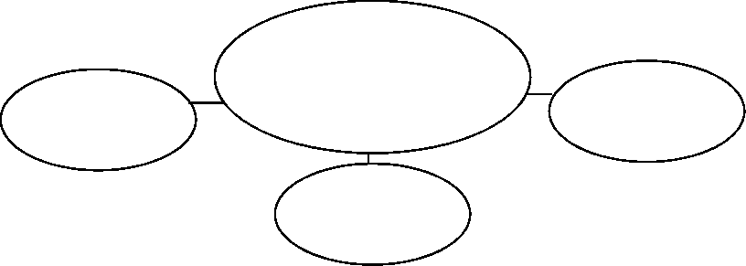
Supporting
Idea here
Main Idea here
Supporting
Idea here
Supporting
Idea here

For some students, recopying their notes is the best method of review. Try it!
For other students, typing their notes works great.
Incorporate PowerPoint slides into your recopied notes.
Once a week, review all of
your notes from the entire
week. This review should be
longer, at least 30 minutes.
By doing a weekly review,
you won’t have to spend as
much time studying when
exams come around.

Other notes on notes:

Label (course title/number/ lecture topic) and date all of your notes.
Use standard abbreviations when taking notes.
For example: Ex= example B/c = because Btw= between W/ = with
Graphic symbols are also great for notes, such as:
* , ( ), [ ], + , = , # , @
Be aware of a wandering mind!
If you notice you are starting to daydream and are not paying attention to the instructor, refocus. Concentrate on your handwriting. Stretch your legs.

