NOTE-TAKING SKILLS & STRATEGIES
Note-Taking Tips
- REVIEW your notes within 24 hours of taking
them. This will help you retain up to 80% of
information for a test.
- Leave spaces in your notes to fill in concepts or
words that you did not write down during lecture.
- Use different colored pens or highlighters to
indicate important concepts.
- Incorporate different learning styles into note-
taking such as walking while reading your notes,
reading them aloud or to other people, and
organizing words or concepts into charts or
concept maps.
- Turn notes into study guides as you review them
so when it comes to test time, you only have to
review your notes.

THE CORNELL METHOD
The Cornell method provides a systematic format for
condensing and organizing notes without laborious
recopying. After writing the notes in the main space, use the
left-hand space to label each idea and detail with a key word
or “cue.”^{i}
METHOD- Rule your paper with a 2-inch margin on the left
leaving a 6-inch area on the right in which to make notes.
During class, take down information in the 6-inch area.
When the instructor moves to a new point, skip a few lines.
After class, complete phrases and sentences as much as
possible. For every significant big piece of information,
write a cue in the left margin. To review, cover your notes
with a card, leaving the cues exposed. Say the cue out loud,
then say as much as you can of the material underneath the
card. When you have said as much as you can, move the
card and see if what you said matches what is written. If you
can say it, you know it.
Print your personalized Cornell Notes at:
http://www.eleven21.com/notetaker

THE CORNELL METHOD
Ex: Cornell Method

Subject: Note-taking | Date: July 27, 2006
Cues: Main Ideas & Questions | Notes & Details
Cornell notes  How will I use Cornell Notes?  Semantic map or web | Can be used to provide an outline of the course, chapter, or lecture. Organized by main ideas and details.  Can be as detailed as necessary.  Sequential: take notes as they are given by instructor or text in an orderly fashion.  After class, write a summary of what you learned to clarify and reinforce learning and to assist retention.  Can be used as study tool:  - Define terms or explain concepts listed on the left side.  - Identify the concept or term based on its definition on the right side.  Can be used to provide a "big picture" of the course, chapter, or lecture.  Organized by main ideas and subtopics.  Limited in how much detail you can represent.  Simultaneous-- you can use this method for instructors who jump around from topic to topic.  After class, you will probably need to "translate" notes into a Cornell format.  Can be used as a study tool -- to get a quick overview and to determine whether you need more information or need to concentrate your study on specific topics.
Summary:
There are a couple of ways that you can take notes. The Cornell method is best when the information is given in a sequential, orderly fashion and allows for more detail. The semantic web/map method works best for instructors who skip around from topic to topic, and provides a "big picture" when you're previewing materials or getting ready to study for a test.

THE OUTLINING METHOD
Dash or indented outlining is usually best except for some science classes, such as physics or math.
- The information which is most general begins at the left with each more specific group of facts indented with spaces to the right.
- The relationship between the different parts is carried out through indenting.
- No numbers, letters or Roman numerals are required, but may be useful in organization.
- Leave spaces to add additional information from
corresponding reading or later lectures.
Outlining works best when the lecture is very organized and sequenced by major points and details. It is more difficult when the speaker talks very quickly or is unclear. Rewriting may be necessary.
Ex: Outlining Method
Extrasensory perception
-Definition: means of perceiving without use of sense
organs
-3 kinds-
-Telepathy: sending messages
-Clairvoyance: forecasting the future
-Psychokinesis: perceiving events external to situation
-Current status
-Few psychologists say impossible
-Door open to future

THE MAPPING METHOD
Mapping is a method that emphasizes concept formation and relationships among concepts. Each fact or idea is related to every other fact or idea. Mapping is a graphic representation of the content of a lecture, textbook or plan for a writing assignment. It is a method that maximizes active participation, organizes knowledge and emphasizes critical thinking.
This format helps you to organize a lecture visually so that relationships can be seen easily. It is also easy to edit your notes by adding numbers, marks and color coding. By covering lines and sections, you can rehearse to remember. Main points can be written on flash or note cards and pieced together into a table or larger structure at a later date. A software program such as “Inspiration” allows easy creation of concept maps for multiple purposes.
This procedure is particularly useful when the lecture content is detailed and well-organized. Using a “map” of notes for review allows you to see relationships among concepts to get the “big picture” as well as to note details.
Ex: Mapping Method
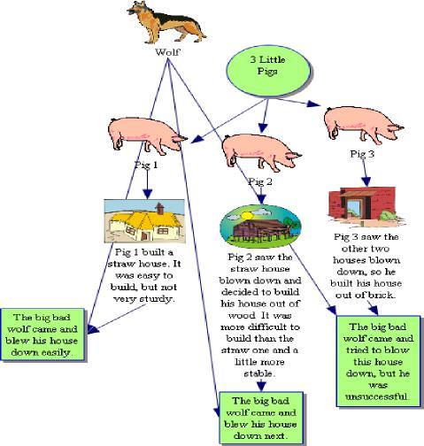

THE CHARTING METHOD
If the lecture format is distinct (such as chronological, comparisons or contrasts), you may set up your paper by drawing columns and labeling appropriate headings in a chart or table.
Determine the categories to be covered in the lecture. Set up your paper in advance with columns headed by these categories. As you listen to the lecture, record information (words, phrases, main ideas, etc.) in the appropriate category.
This method helps organize information that might normally be confusing. It reduces the amount of writing necessary and provides an easy review mechanism for both memorization of facts and study of comparisons and relationships.
This method is best used in courses like history (for chronology) or sociology or other social sciences that have definable categories. It takes time and some experimentation to know when and how to use this system. It is particularly useful when you want to reduce the amount of time you spend editing and reviewing at test time or when you want to get an overview of the whole course on one big paper sequence.
Ex: Charting Method
Drug Name | Drug Class | Effects | Withdrawal Symptoms | Trends
Alcohol,  Benzos, Barbiturates | Sedatives | Slurred speech, slow motor skills, memory loss | Anxiety,  insomnia,  tremors, seizures | Causes 50% all traffic accidents, 3- 4% of population abuse
Amphetamine, Cocaine | Stimulants | Elevated mood, power, decreased appetite | Prolonged sleep, anxiety,  irritability | Highest use in 1970’s

¹ Adapted from Pauk, W. (2001). How to study in college. (7th ed.). Boston, MA: Houghton Mifflin Co.

THE SENTENCE METHOD
Write every new thought, fact or topic on a separate line, numbering as you progress. Ex: Sentence Method
(The teacher would say this in lecture)
A revolution is any occurrence that affects other aspects of life, such as economic life, social life, and so forth. Therefore revolutions cause change. See page 29 to 30 in your text about this.
Sample Note: (what you would write down)
Revolution– occurrence that affects other aspects of life: e.g. econ. social, etc. see text pp. 29- 30.
Use this method when the lecture is somewhat organized, but heavy with content which comes fast. You can hear different points, but you don’t know how they fit
together.
Also, try these tips to get the most out of your notes:
¨ Have the right materials ready to take notes before class, i.e. a good pen or pencil, a notebook or folder devoted to the subject and clean notepaper
¨ Position yourself in the front and center of the classroom so that you are more likely to pay attention
¨ Review, review, review!
Review your notes from previous lectures or the assigned reading before class.
Take 10 minutes after class to glance over your notes and clarify any unclear points, fill in abbreviations, etc.
¨ Try recopying or typing your notes after class for an additional review
¨ Label and date all of your notes with the course title, number and lecture topic

